Unit: 1 |  | Hello English!
Teacher’s name: |  | Bektasova N.A. School: Shubaragash Secondary School
Date: |  | 17.09.2024
Class: 3 |  | Number present: |  | Number absent:
Theme of the lesson |  | Colours
Learning objective (s) |  | 3.1.2.1 recognise familiar words with visual support  3.3.2.2 deduce the meaning of a word in a picture or icon on a limited range of topics  3.4.1.1 spell accurately a few high-frequency words  3.5.1.3 use cardinal numbers 1-10; 11 - 20; 21 – 100
Lesson objectives
Plan
Stages of the lesson | Teacher’s activities |  |  |  | Students’ activities |  | Assessment |  | Resources
Greeting | Teacher greets students; students respond to greeting and take their places.  “Saying hello!” Students are suggested a video “How to say hello in different languages”. Students listen to and compare English “Hello”; then each student shares a greeting he/she memorized and says this greeting to a peer and/or a teacher. |  |  |  | Greeting  Learners listen to and compare |  | Oral assessment |  | video  https://www.youtube.com/watch?v=472AnCrHYVs
Warm-up  Presentation  Practice  Ending the lesson  Feedback | Brainstorming.  - Kids, look at the blackboard, what do you see?  - What balloons do you see?  - How do you think, what theme do you study? |  |  |  | - Balloons!  - Colourful  - Colours |  | Oral  Assessment |  | Colourful balloons
 | Activity1. Listen, point and repeat.  - Ask Ss to open their books to p. 8  - Explain to Ss that they have to listen to the names of colours, point and repeat  - Play the recording and get Ss to repeat, while pointing to the colours’ names.  - Ask Ss to look at the Colours flashcards on the blackboard, listen to the T. and repeat |  |  |  | Students listen to the colours’ names and repeat to memorize them  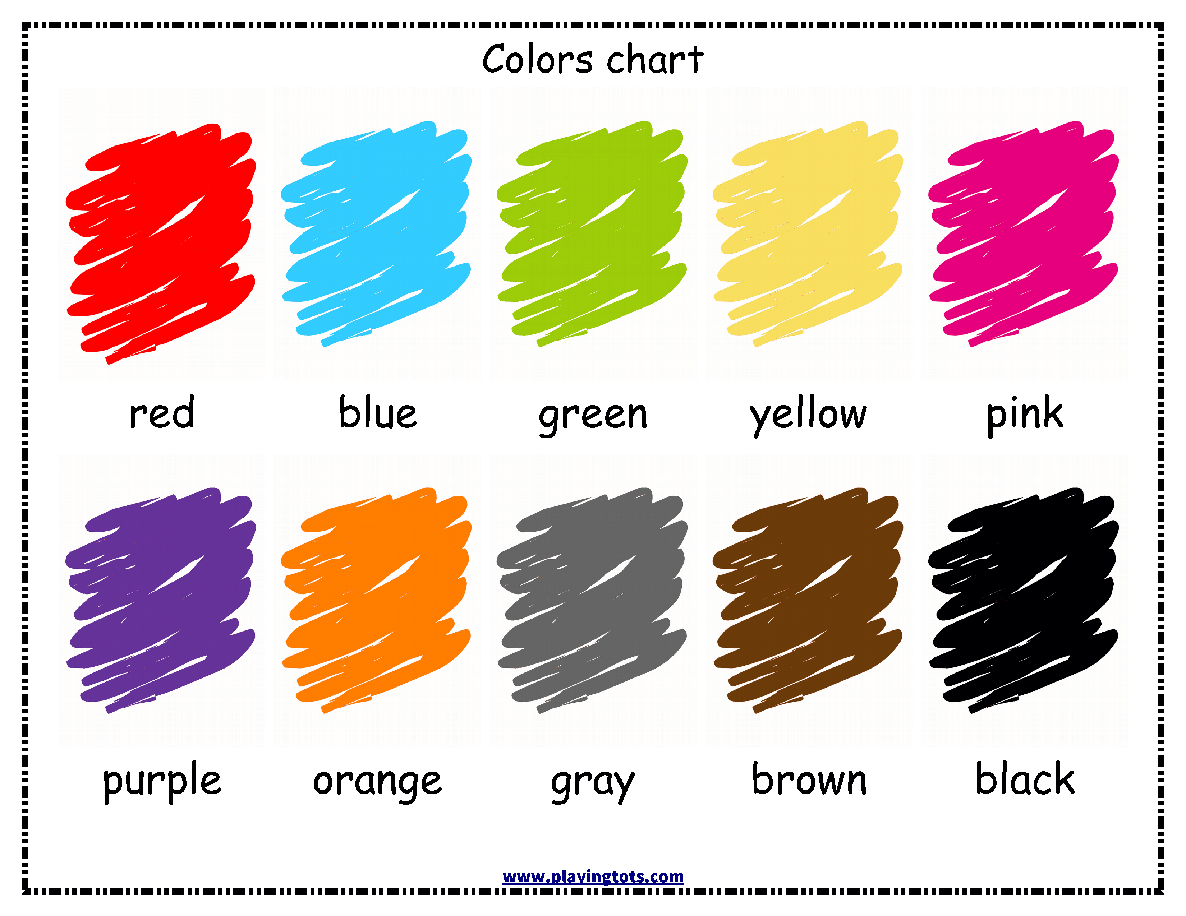 |  | Verbal Assessment |  | Pupil’s Book p.8
 | Activity 2. Write the colour names  - Explain to Ss that they have to write the colour names according pictures |  |  |  | Ss write the colours’ names with visual support |  | Descriptors:  1.yellow – 1p.  2.blue – 1p.  3.green – 1p.  4.red – 1p.  5.pink – 1p.  Total – 5 points |  | Handouts  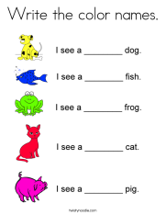
 | Activity 3. Game “Touch the colour”  - .Explain to Ss the game rule  - T names the colour,.. |  |  |  | Ss have to touch something in this colour |  | Oral  Assessment
 | Activity 4. Colour the picture  - Explain to Ss that they have to solve simple maths tasks and colour the picture by answer |  |  |  | Ss solve maths tasks and colour the picture |  | Descriptors:  1.name numbers 1-10 – 1p.  2.solve maths tasks – 1p.  3.read the colour’s name – 1p.  4.colour the pieces of the picture – 2p.  Total – 5 points |  | Handouts  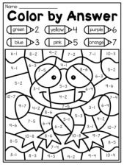
Reflection.
- Teacher suggests to choose any number of fingers 1-4
- 1 – I don’t understand
- 2 – I need a little help
- 3 – Got it!
- 4 – Got it! I can teach someone else
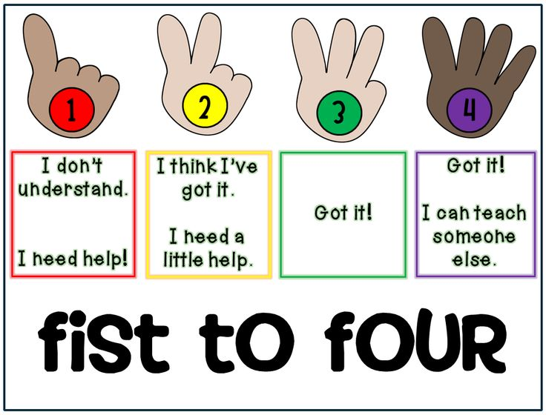
Homework | 1.Learn new words  2.Colour the pencils according their names (the worksheet)
Additional Information
Differentiation - how do you plan to give more support? How do you plan to challenge the more able learners? |  |  | Assessment - how are you planning to check learners` learning? |  |  | Health and safety check ICT links
More support will be given to weaker learners by giving them a modified worksheets in some tasks with greater support |  |  | -through questioning and the redirecting of questioning in feedback activities  -through observation in group and end performance activities  -through formative task |  |  | -White board and video are used no more than 10 minutes  -Use water-based pens  -Health promoting techniques  -Breaks and physical activities used.  -Points from Safety rules used at this lesson.
REFLECTION |  |  | Answer the most relevant questions to reflect on your lesson.  Were the lesson objectives/learning objectives realistic?  What did the learners learn? What did/didn’t you like? What was difficult?

